Addressing deliverables

sdlc model- agile

project scope- create a website that uses facebooks

facetagging api to identify people in user uploaded pictures and pull information

from their facebook profile

limitations- facebook's api limits the facetagging feature to recognize people

in a person's friend list

platform- IE, Chrome, firefox

languages- html, php, css, sql

database- cloud9

repository-github

project host- kaleb's vps

security concerns- sql injection at facebook login. malicious file upload at

"upload picture" button

--database design--

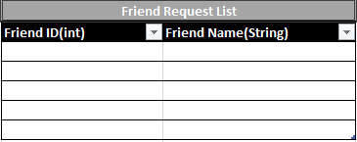

--erd diagram--

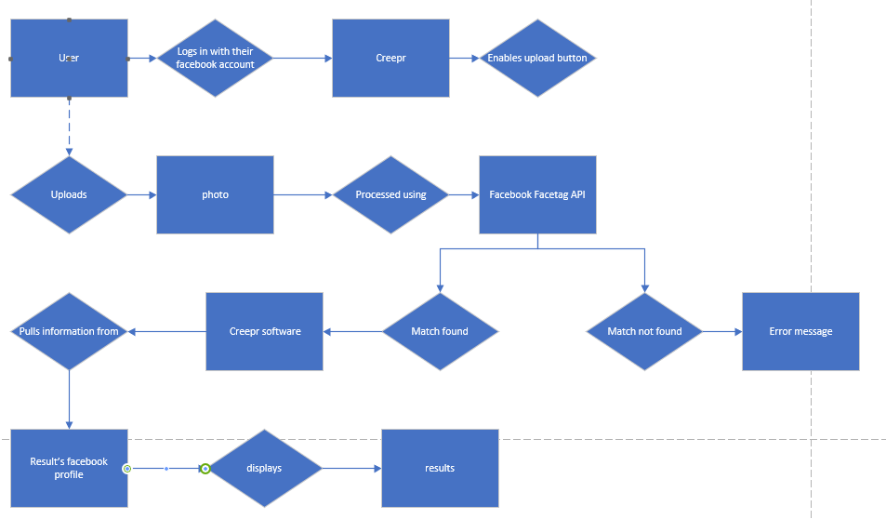

Uml model---

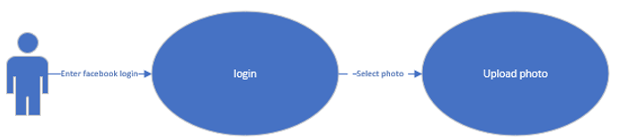

----state diagram----

when not logged in

facebook login button is enabled, "upload picture" button, and logout

are disabled

when logged in- facebook button is removed, "upload picture" button, and logout

are enabled

wireframes-

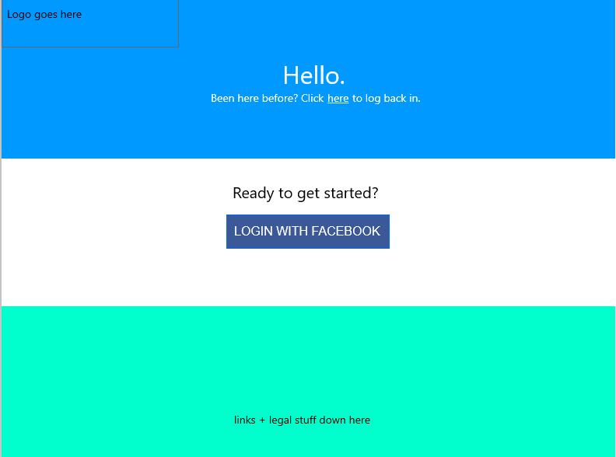

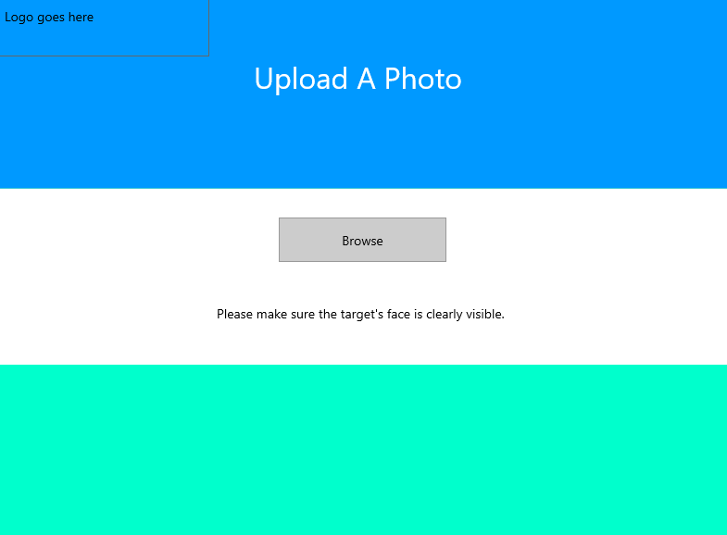

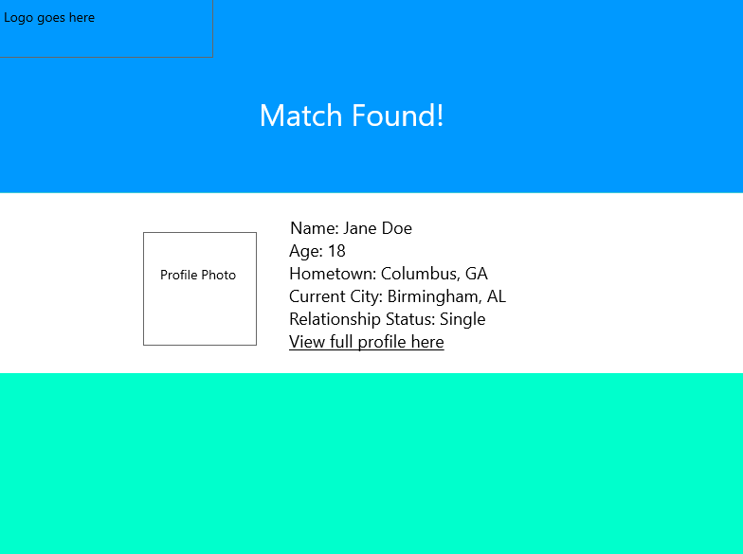

style guide-

Background – blue Top, white middle, aqua bottom

Text- white and black

--design document--

**Design Document**

* 1. **Purpose**

The purpose of the Creepr app is to facilitate everyone’s desire to know more about a person

* 1. **Background**

While it might be considered ethically dubious, it is perfectly legal since the app is only pulling publicly available information. It only takes out the hassle of searching.

* 1. **Scope**

The app aims to use facebook’s publicly available auto-tagging api in conjunction with a facebook bot profile to quickly and reliably pull information on a person of interest.

* 1. **Methodology**

when user visits site, they click the facebook login button and login

the website scans their friend list, and sends friend requests to anyone not already

on the friend request database.

once the user is logged in the "upload picture" button appears.

the user then clicks it and uploads either a png or jpg file of someone.

the facebook api then uses the auto tagging to identify who is in the picture.

if a person is matched, their basic profile data is pulled.

name, age, work, school, contact info, relationship status, etc

Testing strategy document-

Updated project plan-